# Pre-Questionnaire

This questionnaire will be used to identify what the users want the application to be and why. With this data, I will then be able to formulate early designs (sketches and wireframes) of what the application would look like. Overall, this data act as the requirements needed to start designing the application because the definition of the application will be made clear with this data.

This is the questionnaire template that I used to retrieve the data needed to develop the initial wireframe sketches. It contains the questions used as well as the value I got from each question.

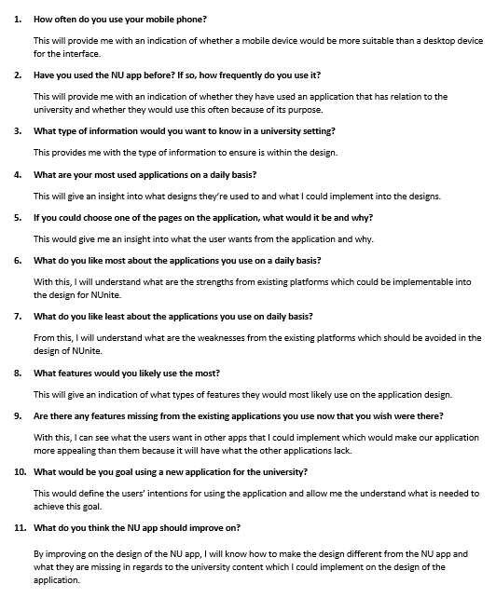

These are the results I gained from the pre-questionnaire that helped me formulate ideas to start the initial designs for NUnite.

|  |  |
| --- | --- |
| **Participant 1** | |
| **Question Number** | **Question Answer** |
| 1 | More than 40 times a day |
| 2 | Yes, don’t use it |
| 3 | I would want to know university events and what students are doing in general to stay in the loop |
| 4 | Facebook Messenger, Instagram, WhatsApp |
| 5 | A post page where users can see what other people are up to around university |
| 6 | I like how simple they are to use and how the layout is familiar |
| 7 | I don’t like how much information there is on some of the applications |
| 8 | I would use a post page and message people often |
| 9 | I wish that there was a place where users could see possible tenancy information considering moving is a part of students’ lives |
| 10 | My goal would be to contact other students and stay aware of university events |
| 11 | I think the NU apps functionality needs improving because I only use the timetable feature, everything else is redundant |

|  |  |
| --- | --- |
| **Participant 2** | |
| **Question Number** | **Question Answer** |
| 1 | More than 60 times a day |
| 2 | Yes, don’t use it |
| 3 | Tenancy info for students that are looking, events around university |
| 4 | Facebook Messenger, Instagram, WhatsApp, Snapchat |
| 5 | A dedicated messaging system where students from similar streams or different streams can talk to each other. |
| 6 | I like that they are all similar so I can transfer using applications easily |
| 7 | I don’t like when you signing up and there’s time you need to learn the system because there is so much going on a once. |
| 8 | I would use the messaging feature most likely on applications |
| 9 | Just wish the layout was less cluttered like Facebooks UI has things that no one even uses anymore as an example |
| 10 | My goal be view posts on tenancy that would help me move places |
| 11 | NU app is redundant at this moment in time because of its limited functionality. |

|  |  |
| --- | --- |
| **Participant 3** | |
| **Question Number** | **Question Answer** |
| 1 | More than 30 times a day |
| 2 | No |
| 3 | What everyone is up to and any news the university has |
| 4 | Facebook, Instagram, Snapchat |
| 5 | I would have a section where users can view posts that other students have done like Facebook |
| 6 | I like the modern style of the apps design |
| 7 | I don’t like cluttered interfaces |
| 8 | I would use the posts page the most because I like keeping up with what students are doing for opportunities |
| 9 | There is nowhere to enable students filter what course they’re one to interact with each other I.E., messaging only computer science students |
| 10 | My goal be view posts on tenancy that would help me move places |
| 11 | The style of NU app is quite dull and boring, maybe using different fonts and layouts could improve the style of the design. |

From this data collected, I knew what I needed to implement and what I needed to avoid when designing the application. This data was used to help me start the designing phase because now I understand the requirements of the user. From here, the sketching and wireframing and be started as initial designs.

The images below show the paper-based sketches and wireframes I completed as the initial designs which were used to influence the first prototype design of the sub-system. These were very important because they gave me an idea of how the application would look and function. These ideas then developed through the prototype in the many versions that now exist through user/stakeholder feedback and group discussions.

